**2048_Project increment3 (group 10)**

Jagadish Tirumalasetty

Murali Krishna Kalvakuri

Prudhvi Nalluri

Sowmya Kamaraju

* First Increment: June 20 (F)
* Second Increment: June 30 (M)
* Third Increment: July 11 (F)
* Fourth Increment: July 21 (M)
* Project Video: July 25 (F)
* Project Presentation: July 29 (T) & July 31 (Th)

**Design and Implementation of Mobile Client:**

2048 is played on a simple gray 4×4 grid, with numbered tiles that slide smoothly when a player moves them using the four gestures (left, right, top and bottom) Every turn, a new tile will randomly appear in an empty spot on the board with a value of either 2 or 4.Tiles slide as far as possible in the chosen direction until they are stopped by either another tile or the edge of the grid. If two tiles of the same number collide while moving, they will merge into a tile with the total value of the two tiles that collided. The resulting tile cannot merge with another tile again the same move. Higher-scoring tiles emit a soft glow.

This is the code for the 2048 game view where view contain the board with 4*4 cells

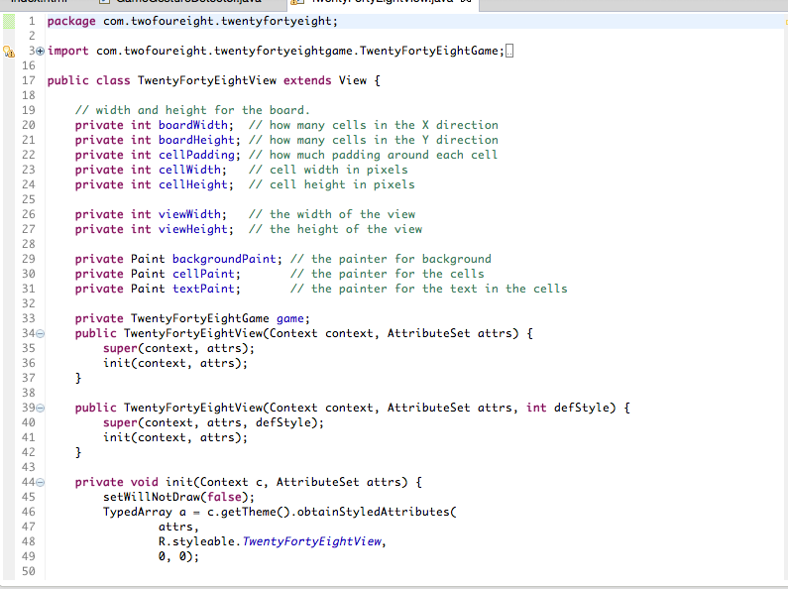

This will be the view of the game

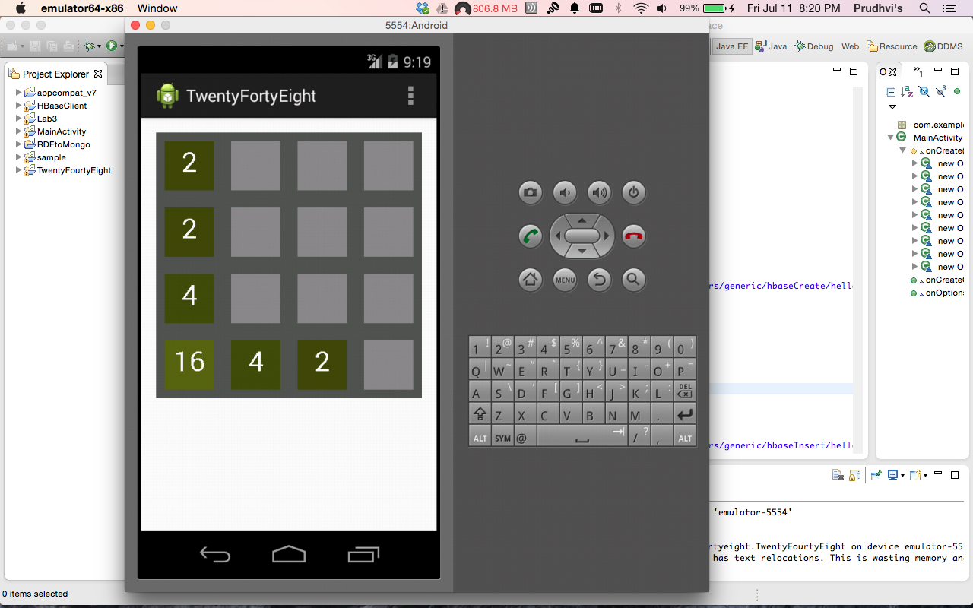

This is the code inorder to detect the moves and respond to the moves whether to right, left, top or down. This is the code we edited to detect and respond to the sensor moves.

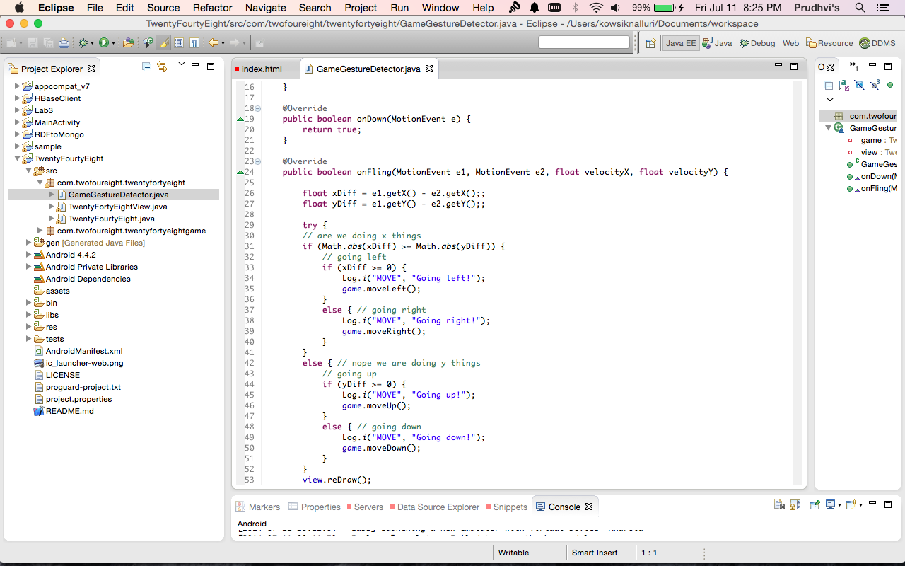

**Design and Implementation of Big Data Analytics:**

For the Activity Recognition made by the sensors, we have taken the data from the sensor and collected the data for each move(left, right, Top, bottom) for 5 times and tranied the data by using the HMMWS model available in blackboard and pushed into the cloudera group floder convert the data into the sequence files using the Restful service given in the lab 4. Now we can detect which action is performed. 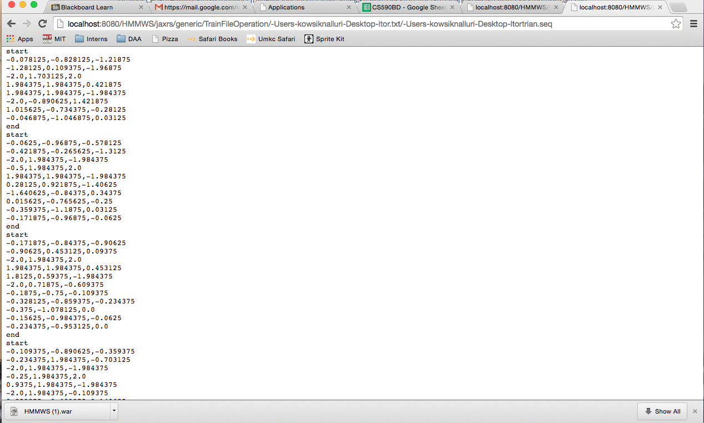

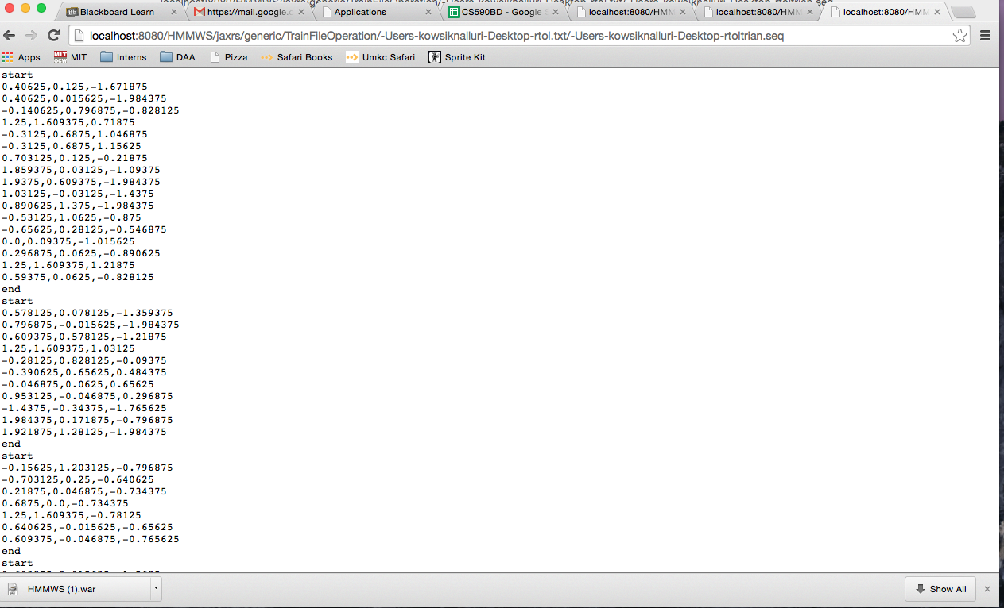

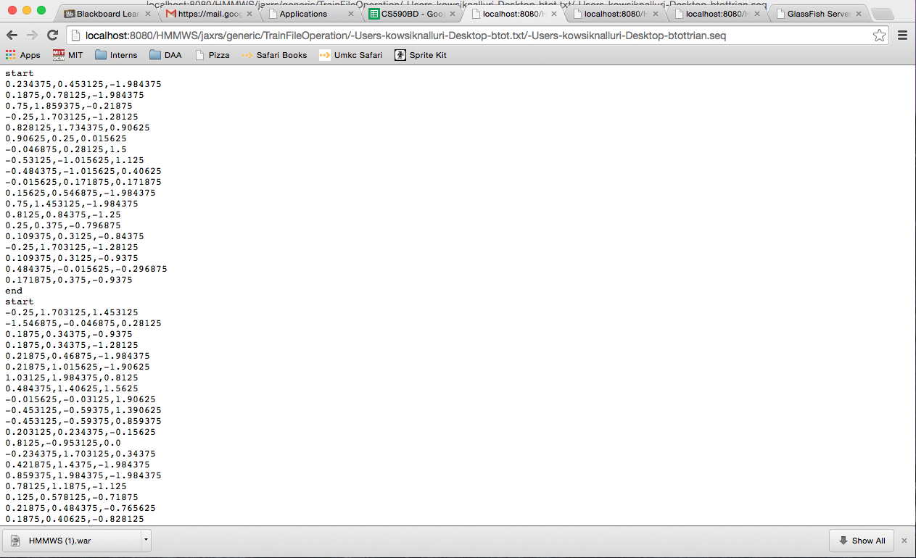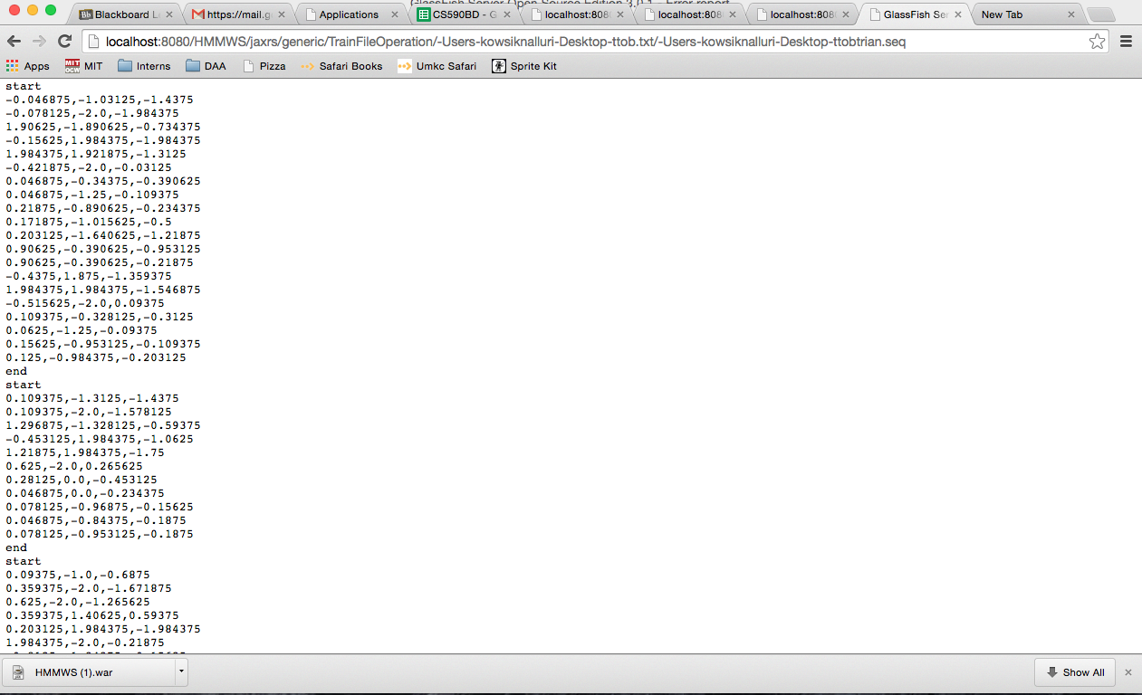

the seqeunce files are generated and test file is also created now we can detect which action is performed by the user.

**Future Work:**

Our future work is to delvelop the game to respond to live actions performed by the user and we have to take somemore data for each action inorder to gain accuracy.

**Github**

https://github.com/PrudhviNalluri/CS5590BD/tree/master/Project%20Increment%203

**Bibliography**

<http://processors.wiki.ti.com/index.php/SensorTag_User_Guide>

<http://en.wikipedia.org/wiki/2048(video_game)>

<https://github.com/uberspot/2048-android>

<https://play.google.com/store/apps/details?id=com.digiplex.game>

<https://github.com/mripley/TwentyFortyEight>